1. What is Computer? - A computer is a programmable electronic device that accepts raw data as input and processes it with a set of instructions (a program) to produce the result as output.

It renders output just after performing mathematical and logical operations and can save the output for future use. It can process numerical as well as non-numerical calculations.

The term "computer" is derived from the Latin word "computare" which means to calculate.

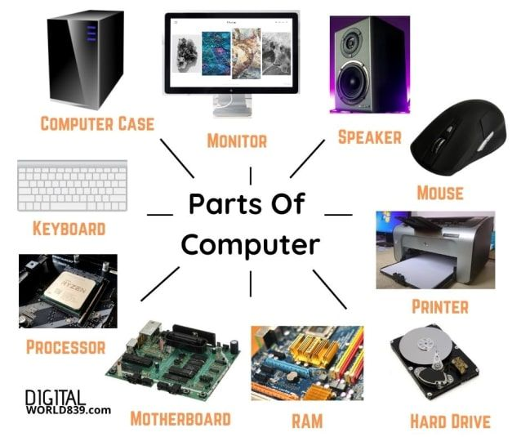2. What are the essential parts of computer? - processor, motherboard, random access memory (RAM), power supply unit (PSU), monitor and solid-state drives (SSD) or hard disk drive (HDD).

3. Who are the notable investors of software and hardware developers?

Hardware

- NVIDIA CORP. (Jen-Hsun ("Jensen") Huang)

- APPLE INC. (Steve Jobs and Stephen Wozniak)

- LENOVO (Lui Chuanzhi)

- INTEL (Gordon Moore and Robert Noyce)

- ADVANCED MICRO DEVICE (Jerry Sanders)

Software

- MICROSOFT CORPORATION (Bill Gates and Paul Allen)

- GOOGLE (Sergey Brin and Larry Page)

- ADOBE INC. (John Warnock and Charles Geschke)

- FACEBOOK (Mark Zuckerberg)

- WORLD WIDE WEB (WWW) (Tim Berners-Lee)

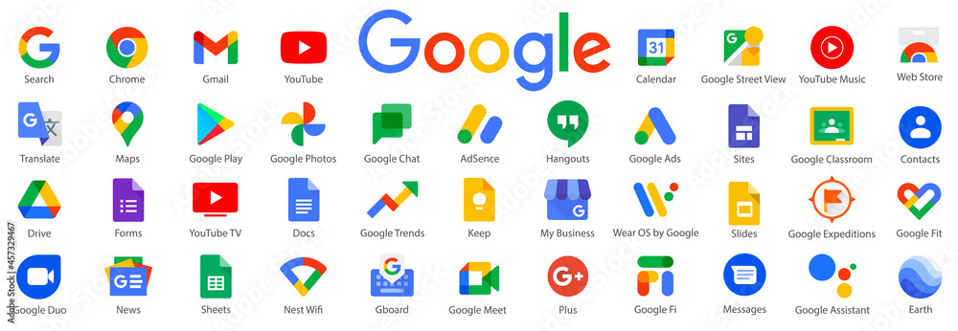  
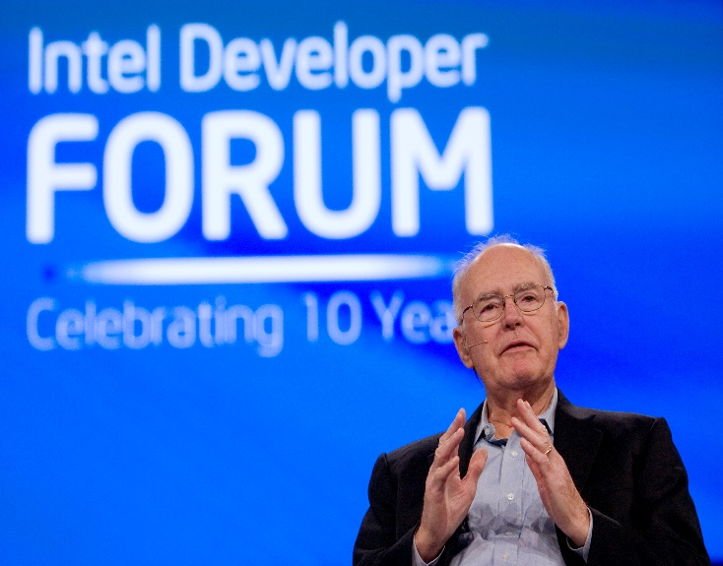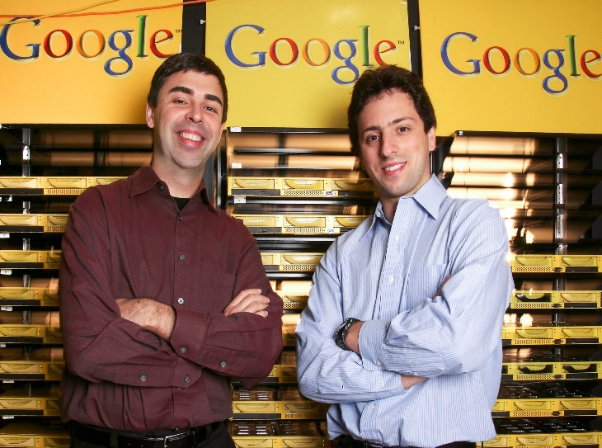  
  
4. Cite your reference

- What is Computer | Types and Advantages - javatpoint. (n.d.-b). www.javatpoint.com. https://www.javatpoint.com/what-is-computer

- Britannica, T. Editors of Encyclopaedia (2024, August 13). NVIDIA Corporation. Encyclopedia Britannica. https://www.britannica.com/money/NVIDIA-Corporation

- Levy, S. (2024, August 13). Steve Jobs. Encyclopedia Britannica. https://www.britannica.com/money/Steve-Jobs

- Liu Chuanzhi. (n.d.). https://www.chinadaily.com.cn/m/beijing/zhongguancun/2011-11/16/content_14025993.htm

- HBS Baker Library. (n.d.). Arthur Rock. Harvard Business School - Baker Library | Bloomberg Center. https://www.library.hbs.edu/Entrepreneurs/resources/persons/arthur-rock

- Britannica, T. Editors of Encyclopaedia (2024, August 10). Advanced Micro Devices, Inc.. Encyclopedia Britannica. https://www.britannica.com/money/Advanced-Micro-Devices-Inc

- Zachary, G. Pascal , Hall, M. and Montevirgen, K. (2024, August 9). Microsoft Corporation. Encyclopedia Britannica. https://www.britannica.com/money/Microsoft-Corporation

- Hall, M. and Hosch, W. L. (2024, August 13). Google. Encyclopedia Britannica. https://www.britannica.com/money/Google-Inc

- Norr, H. R. (2024, August 12). Adobe Inc.. Encyclopedia Britannica. https://www.britannica.com/money/Adobe-Systems-Incorporated

- Hall, M. (2024, August 13). Facebook. Encyclopedia Britannica. https://www.britannica.com/money/Facebook

- Dennis, M. Aaron (2024, July 5). Tim Berners-Lee. Encyclopedia Britannica. https://www.britannica.com/biography/Tim-Berners-Lee